**Individual Assignment #2 Due Friday, April 4 (you should be able to do this during the class blocks this week. Save problem #4 until after the podwork)**

1. For the network *G*, with , find:

a) Find the mean and standard deviation of the degree distribution. (5 pts each)

b) the size of the giant component in *G*, if any. (10 pts)

c) if *G* has 1000 vertices, find the probability that vertex , which has degree 3, and vertex , which has degree 5, have a common neighbor in , which has degree 4. (5 pts)

2. In Chapter 4, “Beyond the Small World”, Watts describes bipartite affiliation networks. Below is an affiliation network for students on a hall and the mathematics classes they are taking this spring. (5 pts each)

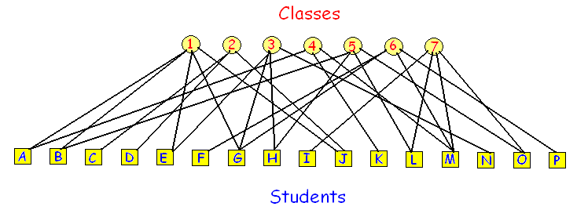

a) Create two separate student affiliation and class affiliation networks from this graph.

b) In the class affiliation network, which class has the highest

i) closeness centrality?

ii) betweeness centrality

|  |  |
| --- | --- |
| 3. Explain this comic to someone outside the class. (5 pts) |  |

|  |  |
| --- | --- |
| 4. Each vertex in a 3-regular grid (hexagonal grid) is colored Red (1) or White (0) uniformly at random. Each vertex selects three neighbors from the field at random and determines its color in the next iteration based on the total of its neighborhood.  a) Perform a **mean field analysis** similar to Wednesday’s podwork and construct the phase portrait in the plane of  and  for the dynamics of the system. (10 pts)  b) What is the steady state (% Red) when  i)  ii)  iii)  (3 pts each) | **Rule Set**  If  total = 0, then White  total = 1, then Red with probability  total = 2, then Red with probability  total = 3, then Red with probabilty  total = 4, then Red. |